Recipe:

Weet-Bix breakfast trifle
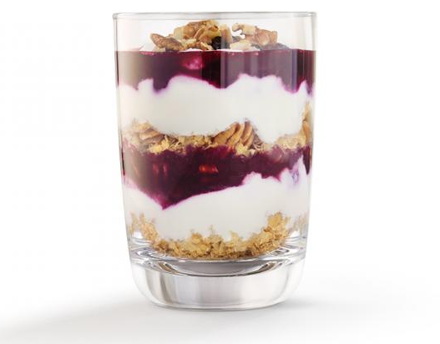
Ingredients
- Wild fruits
- Yoghurt
- 4 Weet-Bix
- Walnuts
Time: 15 minutes
Directions
- Wash your hands
- To start, heat the wild fruits in a frying pan and reduce for five minutes until thick.
- Crush the Wheet-bix.
- Crush the nuts.
- With a spoon, put a layer of wheet-bix in the glass.
- With a spoon, add a layer of yogurt.
- With a spoon, add a layer of wild fruits.
- Repeat steps 5, 6 and 7.
- Add a layer of the walnuts.

