2C - AT THE CINEMA

Hello, guys! I hope you are doing okay during this self-isolation time. I know it’s difficult, but be patient and stay home. We are together in this!
Today, we start with the vocabulary of a new unit –unit 6- (módulo 2C). We will also work a bit on the cultural part of the subject and see how people celebrate Easter (Pascua, in Spanish) in English-speaking countries.
When you finish your activities, email me your exercises in a WORD file to phm_d@hotmail.com. If you have any problems/questions, please, contact me.
Also, if you haven’t sent me your writing activity describing your room, SEND IT SOON! Don’t forget to add the layout (plano).
DEADLINE: Wednesday 8th April. If you can’t complete the activities, let me know.
Miss you, kids! Stay strong!

- Look at the words in the box and copy the vocabulary in your notebook. This is a new unit, so you should prepare a new page.
Science-fiction | Musical | Crime | Romance | Adventure | Fantasy | Documentary
Animated | Comedy | Western | Drama | Horror | Action

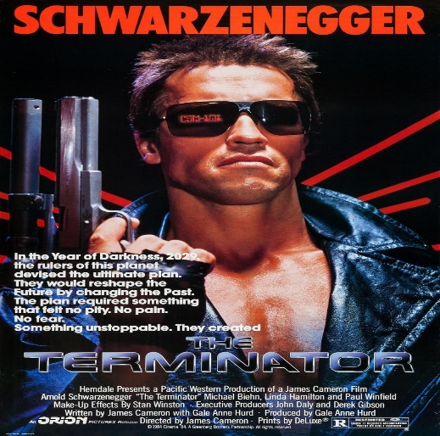
- Now, look at the genres again and think of a title to match to each one. You can do some research on the Internet, ask a friend or a family member if you need to.

Example: A science-fiction movie: The Terminator
(Now it’s your turn. Think of a movie or TV show to match)

- Tick(√) T (true) or F (false)
 | T | F
- A comedy usually makes you cry
- A western has usually got cowboys and horses
- A fantasy film is about real people and places
- An action film has often got fighting in it
- A crime film has often got police detectives in it
- A horror film is usually very sad

- Choose the correct answer.

- Russell Crow plays a detective in this romance / documentary / crime film.
- I sometimes sing along when I watch my favourite musical / western / horror film.
- This romance / drama / fantasy film is about the relationship between a boy and his grandmother.
- Luke Evans plays Dracula in this western / adventure film / horror film.
- In this action film / romance / crime film, a woman meets the love of her life online.
- I love cartoon characters in this musical /western / animated film!
- It’s a documentary / comedy / science-fiction film about zebras in South Africa.
- This is an exciting crime film / horror film / adventure film about a very dangerous journey.

TIP!
You can use both words movie and film. They mean the same thing, BUT ‘movie’ is American English (AE); ‘film’ is British English (BE).
In American English, instead of cinema you can say: ‘Let’s go to the movies, I want to watch Avengers: Endgame’.

- Complete the sentences so they are true for you.

- I like ______________ films because _________________________________.
- I don’t like ______________ films because_____________________________.

- Write the words in the correct order to make sentences. Check if the final result makes sense and email me any possible doubts you may have.

- Tomb Raider / film / action / an / is: ___________________________________.
- is / It / Lara Croft / about: ____________________________________________.
- to / Lara / find / father / her / wants: ____________________________________.
- stop / Matthias Vogel / her / to / tries: ___________________________________.
- this / In my opinion, / film / is / great / a: ________________________________.

- Read the film review. The word order is not correct in the underlined words. Rewrite the sentences with the correct word order in the space below.
Roxanne Roxanne
A review by: Wayne Best Year: 2017
Genre: musical drama Length: 98 minutes

Roxanne Roxanne is an interesting film about the life of Roxanne Shante, a 1980s rapper from New York.
Life is very hard for Roxanne and her three sisters because their mother is an alcoholic. One day, she performs in a rapping competition and her voice amazing is. Marley, a music producer, thinks Roxanne is a talented rapper and decides to record her. People hear her song on the radio and like it they. Marley invites Roxanne to come on tour with him. She enjoys the tour and she gives some performances exciting. At first, she is happy, but her life becomes complicated when she meets a criminal.
In my opinion, Roxanne an excellent film is with great music. Go and see it!

- Now write the underlined sentences in the correct order:
- ______________________________________________.
- ______________________________________________.
- ______________________________________________.
- ______________________________________________.

- Here you have some adjectives to describe movies. Copy these words in your notebook. You can use a dictionary.
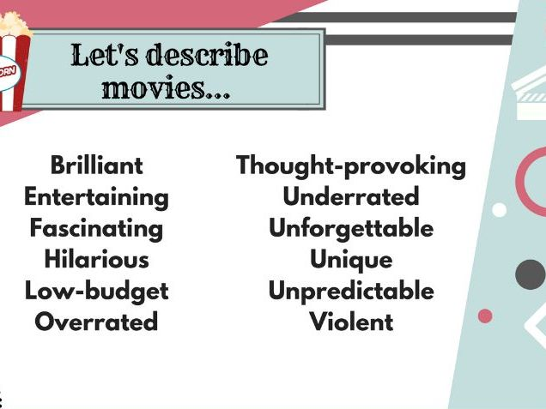

- Now it’s your turn to write a film review.

- Choose a film (any genre that you like) and think (or look for the information) of the following aspects:

- Name of the film:
- Genre:
- Year:
- Length:
- Plot:
- Main characters:
- Opinion:

- If you have all the information that you need, you are ready to write your own film review. Follow the example above.
Remember to use the adjectives that you copied in your notebook and divide the information into paragraphs. Use some linking words (At first, after that, finally…). Send your writing to my email in a Word file.
First paragraph: general information of the film
Second paragraph: plot of the film, what is the film about?
Third paragraph: your opinion

EASTER
(PASCUA)

You can find the words from the puzzle in the text. It is Easter vocabulary.
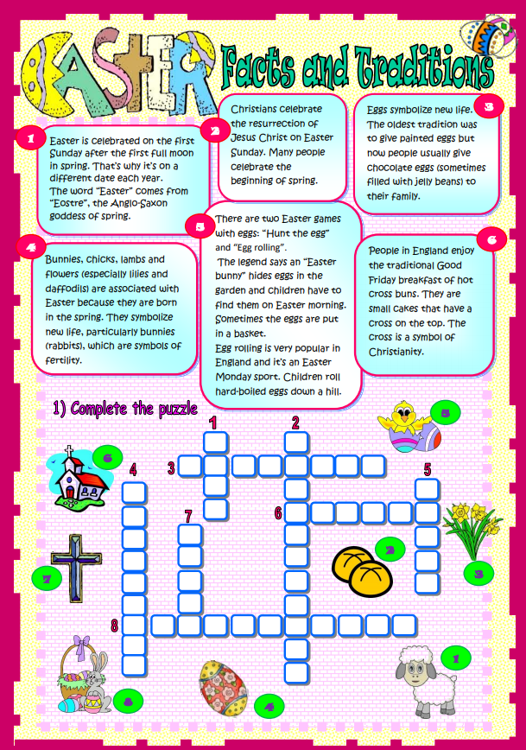
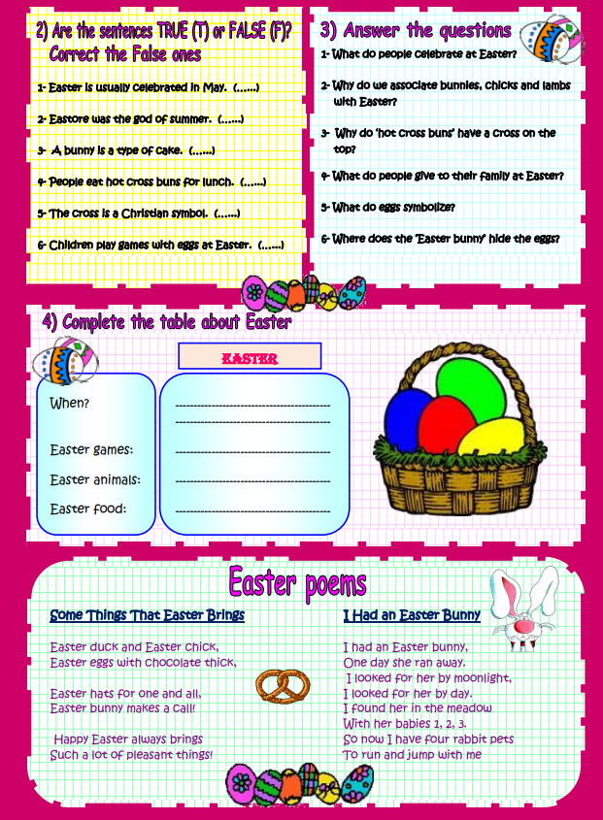
READING
An Easter Story
Marsha’s favourite time of the year is spring and her favourite holiday is Easter. Marsha loves to paint eggs for Easter. She usually paints the eggs different colours like red, green, blue, pink and purple. She doesn’t like yellow or orange so she never paints her Waster eggs yellow or orange.
Marsh also likes putting the eggs in the garden so her sister, Tina, can find them. After Tina finds the eggs, the sisters eat the special chocolate bunnies that the Easter Bunny leaves for them each year. Tina always gets a white chocolate rabbit because she is allergic to chocolate. Marsh thinks white chocolate is delicious and believes her sister is very lucky.

- After reading the text, say if the following sentences are T (true) or F (false).

- Marsh likes spring:
- Marsha’s favourite holiday isn’t Easter:
- She always paints her Easter eggs yellow, blue and pink:
- Marsha puts the eggs in the living room:
- Her sister’s name is Tina:
- Santa Claus always brings the girls chocolate Easter bunnies:
- Marsh always receives a white chocolate rabbit:
- Marsha’s sister is allergic to chocolate:

- Answer the questions:

- What’s Marsha’s favourite holiday? ___________________________________.
- What colours does Marsha dislike? ____________________________________.
- Where does Marsha put the Easter eggs? ________________________________.
- Does Marsha think white chocolate is good? _____________________________.

