CHECK YOUR PROGRESS

- Circle the things that need air and water to live.

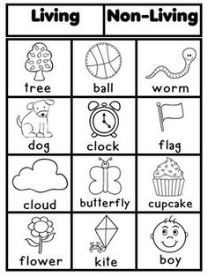

- Look at the picture above and draw 6 living things and 6 non-living things.

LIVING THINGS NON-LIVING THINGS

- What are the properties of air?

Circle the correct answers
(Four of them are correct)

- We can see air.

- We cannot see air.

- We cannot taste air.

- We cannot smell air.

- Air is everywhere.

- We can smell air.

- Draw the arrows where the wind moves.

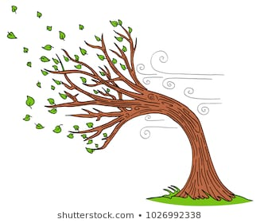

- Draw a landscape with mountains, a river, a lake and the sea.

Complete the following sentences with:

SALT WATER or FRESH WATER:

Rivers and lakes are …………………… …………………… .

The sea is ……………………… ………………………... .

- Look and circle in the right colour.

DRINK COOK WASH

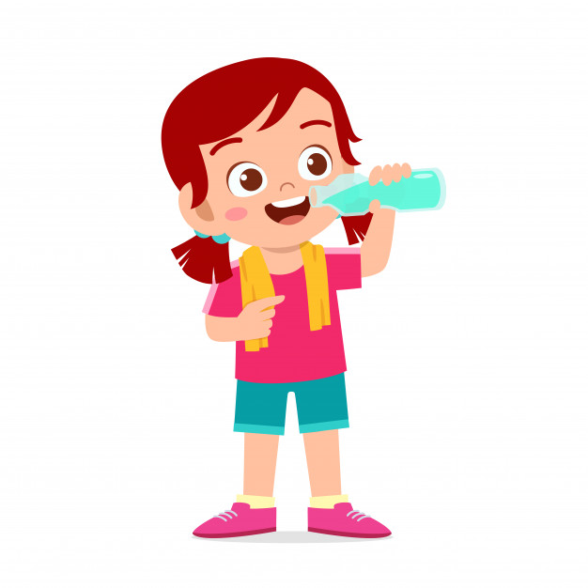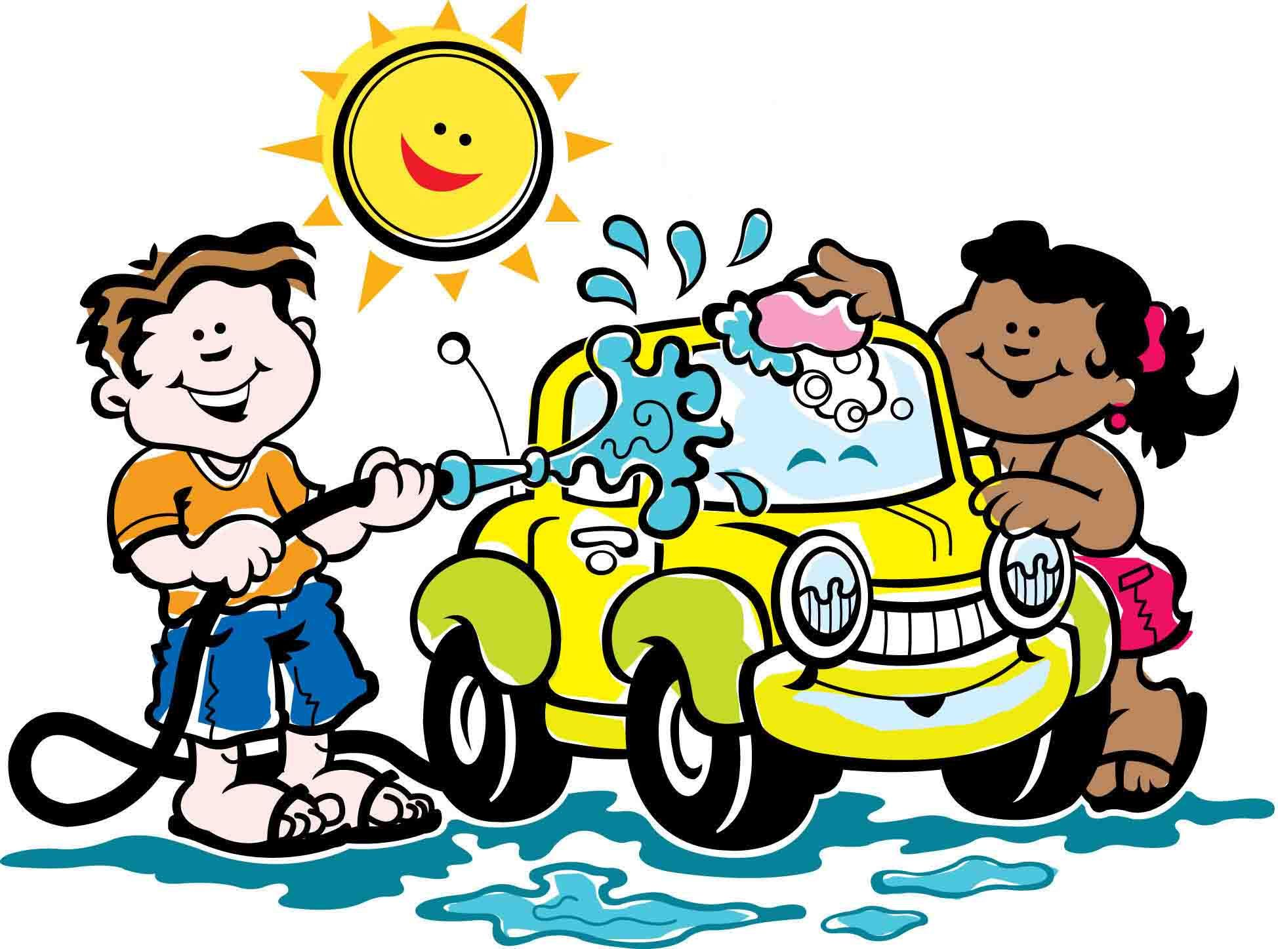

- How can you save water?

Draw 2 actions that we can do to save water.

- Look at the pictures and write CLEAN or DIRTY.

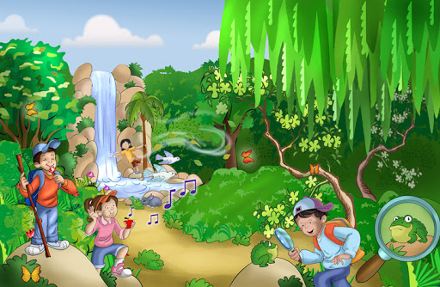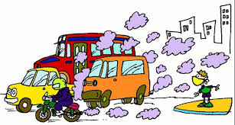

…………………. AIR. ……………………. AIR.

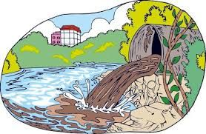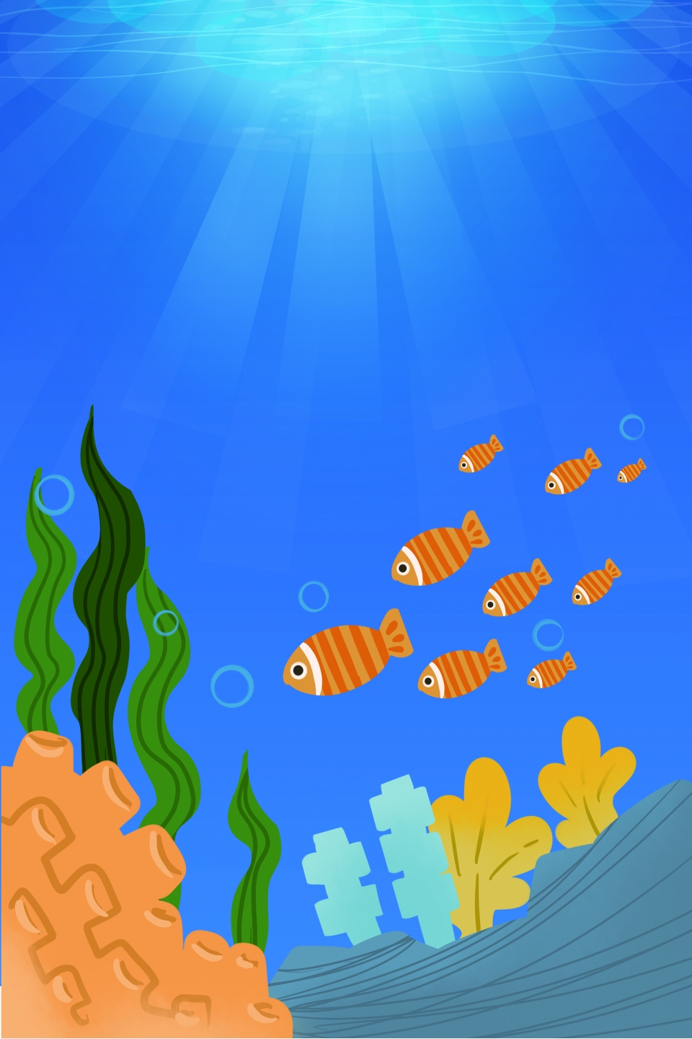

…………………. WATER. ……………………. WATER.

