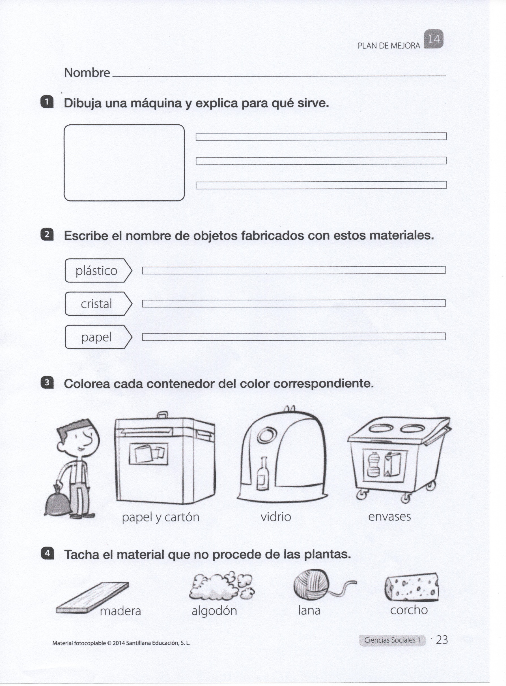

[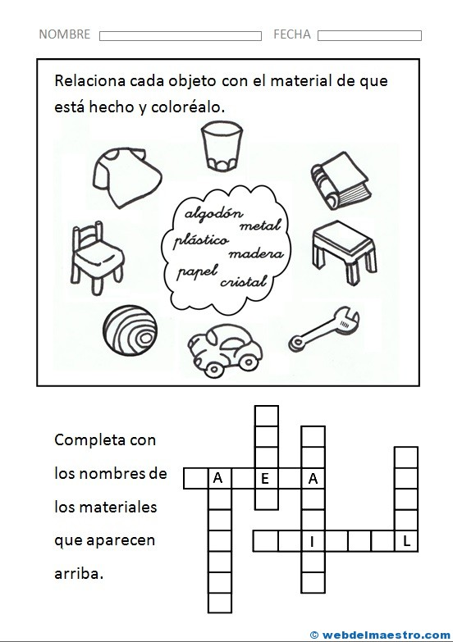](https://www.google.es/url?sa=i&url=https://webdelmaestro.com/tipos-de-materiales/&psig=AOvVaw25hgoT1I5mh_J7Z7JLKYcb&ust=1584554323762000&source=images&cd=vfe&ved=0CAIQjRxqFwoTCMiDwICLougCFQAAAAAdAAAAABAJ)