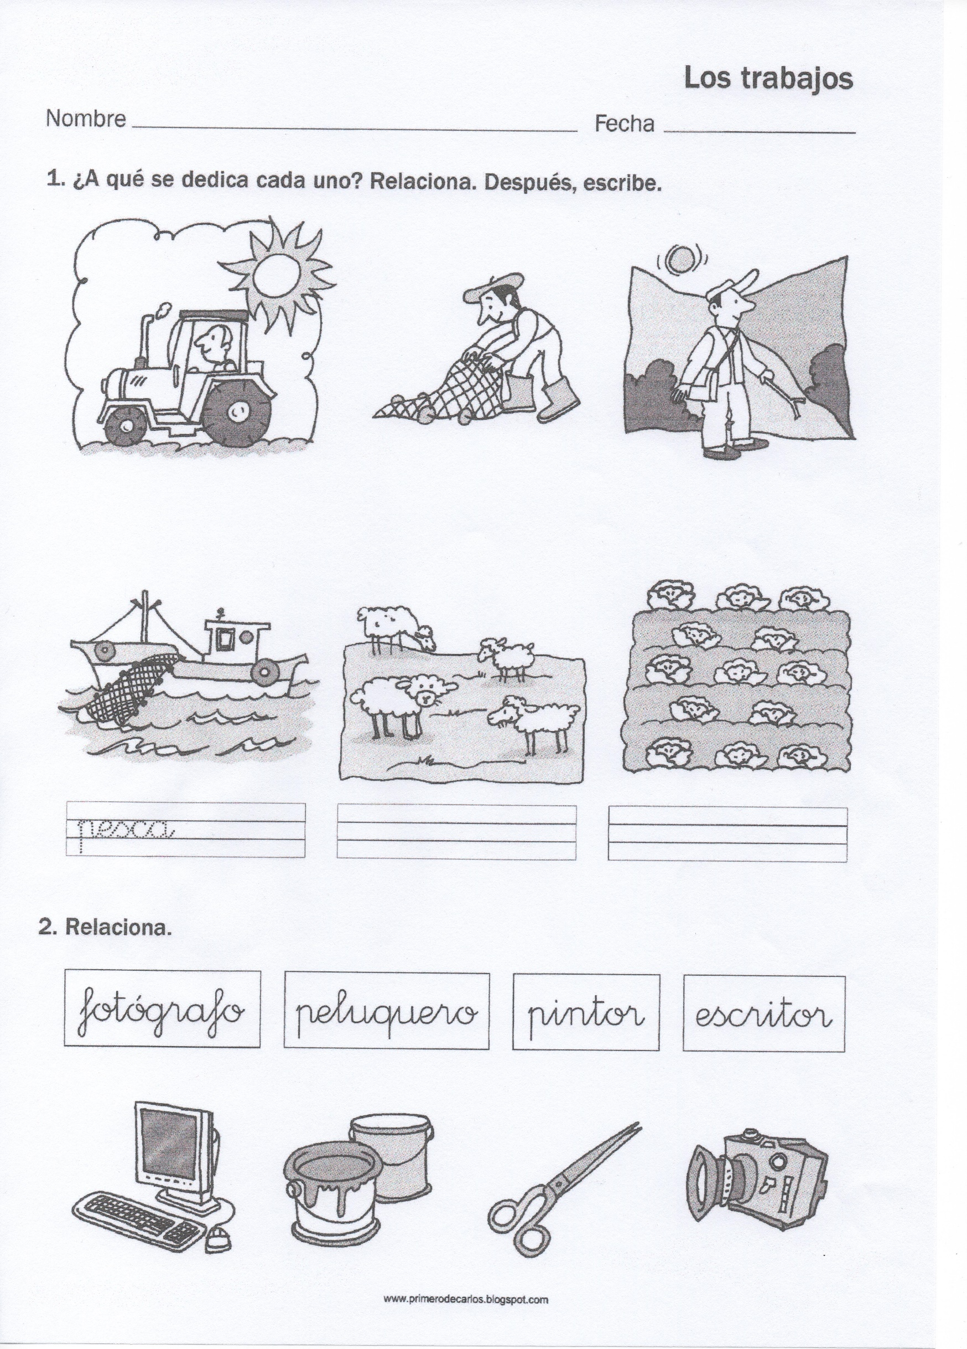

[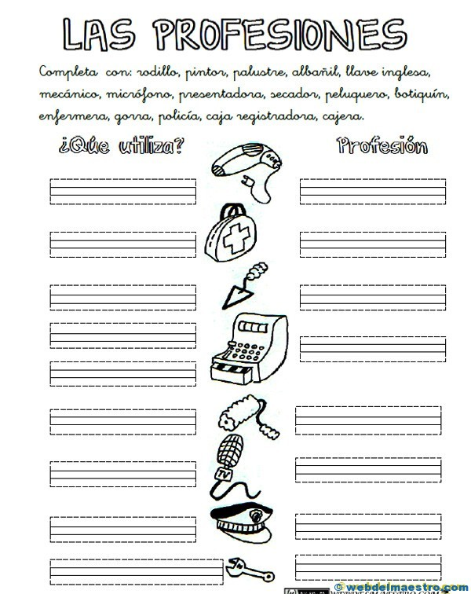](https://www.google.es/url?sa=i&url=https://webdelmaestro.com/las-profesiones/&psig=AOvVaw2hJJ3Oq4WVSS5wVNfSD9EC&ust=1584553971350000&source=images&cd=vfe&ved=0CAIQjRxqFwoTCPDhv9eJougCFQAAAAAdAAAAABAD)